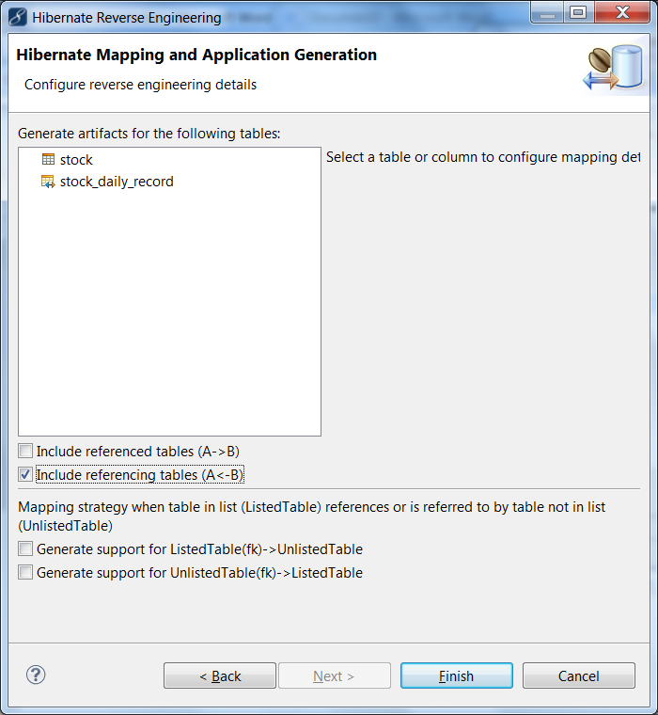

One to Many, Stock is parent to Stock_daily_record

